**PROJECT- 5:**

**AIM: Hosting a static website in AWS S3.**

S3 (Simple Storage Service):

* Amazon Simple Storage Service (S3) is a scalable cloud storage service provided by Amazon Web Services (AWS).
* It allows you to store and retrieve data from anywhere on the web. S3 is highly reliable, durable, and designed to provide 99.999999999% (11 nines) of data durability.

Here are some key features and concepts related to S3 in AWS:

* Buckets: A bucket is the fundamental container for objects stored in S3. It acts as a top-level folder or directory that holds your files. Each bucket has a globally unique name and is associated with a specific AWS region.
* Objects: An object is a file or piece of data stored in S3. Each object is uniquely identified within a bucket by its key (file name) and can be up to 5 TB in size.
* Access Control: S3 provides flexible access controls to manage the permissions and security of your data.
* S3 offers different storage classes to optimize cost and performance based on your data's access patterns.
* The storage classes include Standard, Intelligent-Tiering, Standard-IA (Infrequent Access), One Zone-IA, Glacier, and Glacier Deep Archive.

Working with S3

Steps:

1.First we need to create a S3 bucket so got S3 management console and click on create bucket.

2.Provide a unique name for bucket.

3.Grant the public access as we are hosting a static website globally.

4.Disable versioning, bucket key and leave encryption as SSE-S3.

5.Upon clicking on create bucket you can see our bucket has been created.

6.As we are trying to host our website, we need to upload our files regarding website.

* upon selecting the bucket click on upload.

7.Click on add files option to add files.

8.After adding the files click on upload.

9.You can see our files are uploaded successfully.

10.Now go to properties as you scroll down you can see static website hosting.

11.Enable the static website hosting and provide the index and error html pages.

12.Select all the file and in action dropdown select make public using ACL. By doing this we can make all these public.

13.You can see a link will be formed under static website hosting. This is used to access our website.

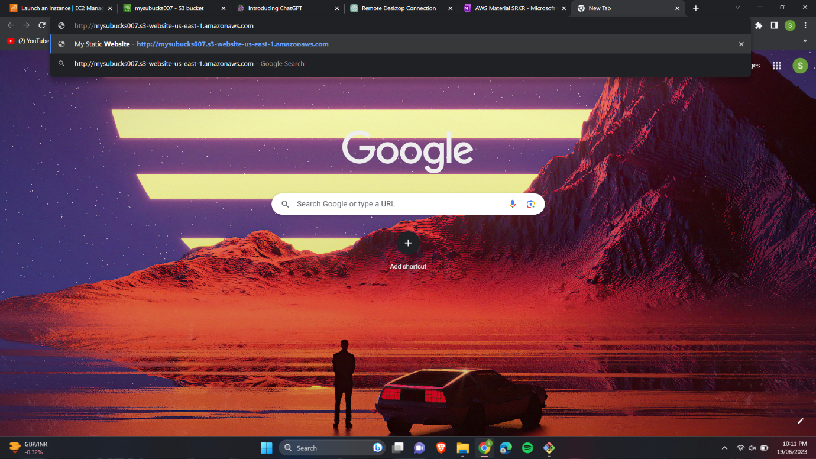

14.You can see our website.

